ENGL1105 Project #3: Worknets

# Overview

Researched academic sources are a mainstay of *many* academic disciplines. They are how academics account for research activity—posing difficult questions and detailing studies that seek to inform some research question, to share evidence, or to circulate findings.

Worknets introduces you to a method for reading and writing your way across *one* researched academic source and thereby accounting for its generative connections. Worknets help readers comprehend and remember the important parts of an article, but they also prompt new researchable questions that can lead to emerging research interests for the reader.

Importantly, worknets consist of a series of phases which expand upon the article’s discoverable ties to keywords, sources, authorship, and the world (time and place) in which it was written. We should think of worknets as helping us engage sources visually and in writing so that we are better able to use the source toward rhetorical invention. Worknets also help us grasp the rhetorical situation in which the article was produced—who wrote the article, what their purposes were, who the audience was, and how the article has circulated or been taken up.

# Choosing an Academic Article

Select *one* of the articles in the list below to complete your worknets project. ***OR*** you may propose an article to me (must be more than 10 pages long, must be from a peer-reviewed journal, must have reasoning for use).

Bos, Nynke, et al. “The Use of Recorded Lectures in Education and the Impact on Lecture Attendance and Exam Performance.” *British Journal of Educational Technology*, vol. 47, no. 5, Sept. 2016, pp. 906-17. *EBSCOhost*, <https://doi-org.ezproxy.lib.vt.edu/10.1111/bjet.12300>.

Goel, Rajeev, and Michael Nelson. “Do college anti-plagiarism/cheating policies have teeth in the age of AI? Exploratory evidence from the Internet.” *Managerial and Decision Economics*, vol. 45, no. 4, pp. 2336-47. *Wiley Online Library*, <https://doi-org.ezproxy.lib.vt.edu/10.1002/mde.4139>

Grzimek, Volker, et al. “Attitudes about Classroom Group Work: How Are They Impacted by Students’ Past Experiences and Major?” *Journal of Education for Business*, vol. 95, no. 7, Oct. 2020, pp. 439-50. *EBSCOhost*, <https://doi-org.ezproxy.lib.vt.edu/10.1080/08832323.2019.1699770>.

Kitsantas, Anastasia, and Barry Zimmerman. “College Students’ Homework and Academic Achievement: The Mediating Role of Self-Regulatory Beliefs.” *Metacognition & Learning*, vol. 4, no. 2, Aug. 2009, pp. 97-110. *EBSCOhost*, <https://doi-org.ezproxy.lib.vt.edu/10.1007/s11409-008-9028-y>.

Schejbal, David. “General Education Reconsidered.” *The Journal of General Education*, vol. 66, no. 3–4, 2017, pp. 217-34. *JSTOR*, <https://doi.org/10.5325/jgeneeduc.66.3-4.0217>.

# How To Make A Worknet

| An example of a complete WorkNets visual, with all four phases represented. |
| --- |
| Figure 1: A completed worknet. |

Use Google Drawing (Insert→Drawing→New) to create your worknets. It might take some time to get familiar with the drawing tools; we will spend time in class practicing using the tools and creating the worknet phases. **Important: Be sure to save a version of the model *after* each phase so you can easily show its build-up.** Using a hub and spoke model, draw links from the central node (the article author, title, and year of publication) to a series of surrounding nodes. Create 4-5 nodes for each of the following four phases: ***semantic***, ***bibliographic,*** ***affinity-based***, and ***choric***. Be sure to complete ONE PHASE AT A TIME.

## Written Components

**A written account (approximately 300-400 words) accompanies each visual phase.** That’s four phases, four accounts. Each written account addresses the choices you made in creating that phase of the worknet; responds to questions noted in association with each phase; and brings to light relevant noticings at that phase. Your completed project will also include an opening paragraph that introduces the article’s purpose, audience, and context using rhetorical terms and concepts we have discussed this semester and a concluding paragraph in which you critically engage with the content and/or composition of the article. In total, the written components of the project (intro, four phases, conclusion) will be **1800-2400 words.**

## Introduction Paragraph

In the opening paragraph(s) of your worknets project, introduce your chosen article, including the writer(s) name(s) and title of the article. Provide a summary of the argument and briefly discuss the article’s rhetorical situation (as discussed in Project 2), such as the author’s purpose, intended audience, author’s stance, language used, medium and design, or other contextual factors.

## Phase 1: Semantic

***Semantic***: concerns vocabulary—words and phrases that appear in the article itself and whose reference and meaning can be traced to peripheral ideas suited to further exploration. Whether you seek individual words or two-word phrases, **include the total count in parentheses** (i.e., the number of times the word/phrase appears in the article), and **select 4-5 key terms or phrases.** There are online tools to help with this, such as [Tagcrowd.com](https://tagcrowd.com/), [Voyant Tools](https://voyant-tools.org/), and the Online NGram Analyzer at <http://guidetodatamining.com/ngramAnalyzer/>. In the written account that goes with the semantic phase, discuss *at least two* of the following prompts:

* What do the terms mean, both in general and in the context of the article?
* Why are these terms important? How do they advance the rhetorical goals (including purpose) of the piece?
* How do the keywords favor a particular audience, showing that audience regard for forms of knowledge that are important to them?

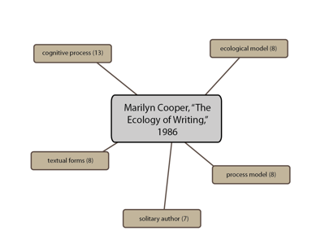

## Phase 2: Bibliographic

***Bibliographic***: traces specific sources cited in the original. For this phase, turn to the works cited or references list at the end of the article. **Choose 4 sources.** In the written account that goes with this phase, discuss *at least two* of the following prompts:

* What are the dates of publication? Is this important for the meaning of the piece?
* How do the sources appear in the article? That is, how are they being used? Are they being critiqued or praised? Are they providing background information? etc.
* How might tracking down any one source expand your knowledge about the article and its rhetorical context?
* In what ways do specific sources advance the rhetorical goals of the piece?

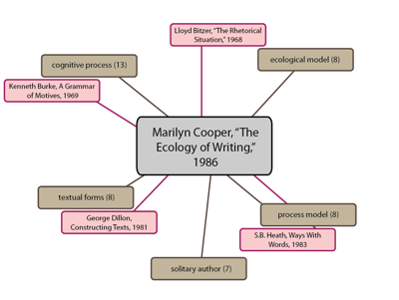

## Phase 3: Affinity-based

***Affinity-based***: attends to functions of authorship, such as graduate training, collaborations, current position, career arc for publishing activity, and relationship to other specializations. For the affinity-based phase, look up the author. In the written account, discuss *at least two* of the following prompts:

* What else has the author written? What other work have they done?
* Do they publish by themselves or with others? Does it seem to you their other works are related to the focus of this article? How so?
* Where does the author work? How long have they worked there?
* How does the affinity phase give you a deeper sense of the author’s credibility, qualifications, or *ethos*?  
    
  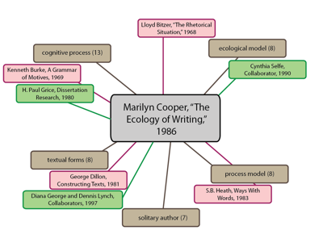

## Phase 4: Choric

***Choric***: This phase examines the world in which the article was written, collecting a handful of pop culture references from the time and place it came from. Like the affinity worknet above, a choric worknet is not explicitly identifiable *in* the text of the article. It sets you up to explore events from popular culture (movies, songs, happenings, local and world news) in the interest of enlarging context and striking juxtaposition. In the written account, discuss *at least two* of the following prompts:

* What else, specifically, was happening when the article was written?
* What was going on in the place where it was written?
* How do a sample of these time-place associations open up new possibilities for exploring the article or an idea it introduces?

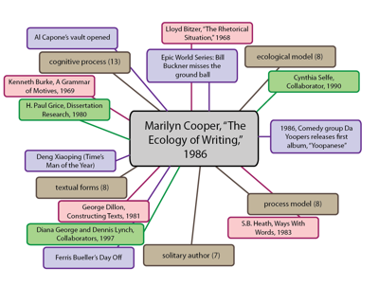

## Conclusion Paragraph

In the final paragraph, *critically engage* with the content and/or composition of the article. Consider incorporating responses to ***two***of the following questions for this paragraph.

* Where do you agree/disagree with the author, and why?
* Where is the author most/least convincing?
* How does the author encourage you to think differently about an issue?
* How does the author help you better support a position you already hold on the issue?
* Why does this article/argument matter? How does it relate to our conversations regarding language and/or writing?

# Formatting

Your worknets project should:

* Be at least **1800 words.**
* Have **neat and purposeful** visual components.
* Have a **creative and fitting title** (something that describes your findings in analyzing the piece)
* Include an **MLA heading** (Name, Instructor’s Name, Course, Date) in the top left-hand corner.
* Use **purposeful** punctuation, grammar, and syntax to enhance your accounts.

# Due Dates

* A half-draft of at least 900 words is due by ___.
  + Half-drafts will feature an introduction, written accounts for Phases 1 and 2, and visuals from Phases 1 and 2.
* A final draft of 1800-2400 words is due by ___.
  + Final drafts will feature an introduction and conclusion, written accounts for all phases, and visuals from all phases.

# Grading

## *Half-Draft:* graded on a scale of 100 points

|  | Excellent Work (20 points) | Great Work (15 points) | Acceptable Work (10 points) | Needs Growth or Revisiting (5 points) |
| --- | --- | --- | --- | --- |
| Phase 1 Visual | Visual has 4+ nodes with # of time key words appear | Visual has 3-4 nodes; may be missing the # of times key words appear | Visual has only 1 or 2 nodes (or is combined with the second visual) | Visual is missing |
| Phase 2 Visual | Visual has 4+ nodes with author names, publication years, and titles of sources (may be shortened) | Visual has 3-4 nodes, may be missing author names, publication years, or titles of sources (may be shortened) | Visual has only 1 or 2 nodes (or is combined with the first visual) | Visual is missing |
| Phase 1 Writing | 300+ words, answers at least 2 of the prompt questions in detail | 250-300 words, answers at least 2 of the prompt questions, but answers may remain unclear | 200-250 words, answers 1 of the prompt questions in detail | Less than 200 words OR did not write for this phase |
| Phase 2 Writing | 300+ words, answers at least 2 of the prompt questions in detail | 250-300 words, answers at least 2 of the prompt questions, but answers may remain unclear | 200-250 words, answers 1 or the prompt questions in detail | Less than 200 words OR did not write for this phase |
| Formatting and Style | Includes all header information (name, instructor name, course, and date) & sections are clearly labeled or separated | May miss one portion of header information (name, instructor name, course, or date) & sections are clearly labeled or separated | May miss two portions of header information (name, instructor name, course, or date) & sections are labeled (but may be unclear) | Does not include header information OR phases of text are unable to be determined |

**-5 points for every hour late, no submissions accepted after 12 hours**

**Automatic 0 - No submission**

## *Final Drafts*: graded on a scale of 150 points

|  | Excellent Work (10 points) | Great Work (7 points) | Acceptable Work (4 points) | Needs Growth or Revisiting (1 points) |
| --- | --- | --- | --- | --- |
| Phase 1 Visual | Visual has 4+ nodes with # of time key words appear | Visual has 3-4 nodes; may be missing the # of times key words appear | Visual has only 1 or 2 nodes (or there is only one visual for all 4 phases) | Visual is missing |
| Phase 2 Visual | Visual has 4+ nodes with author names, publication years, and titles of sources (may be shortened) | Visual has 3-4 nodes, may be missing author names, publication years, or titles of sources (may be shortened) | Visual has only 1 or 2 nodes (or there is only one visual for all 4 phases) | Visual is missing |
| Phase 3 Visual | Visual has 3+ nodes with clearly relevant information about the author’s additional work | Visual has 2-3 nodes, may include information that is not obviously related to the author | Visual has only 1 node (or there is only one visual for all 4 phases) | Visual is missing |
| Phase 4 Visual | Visual has 3+ nodes referring to events occurring within the same year of publication | Visual has 2-3 nodes, but may refer to 1 or more events that occurred in other years (not the one of publication) | Visual has only 1 node (or there is only one visual for all 4 phases) | Visual is missing |
| Introduction Writing | 300+ words, introduces author, publication year, and summarizes article in detail | 250-300 words, introduces author, publication year, and somewhat summarizes article | 200-250 words, introduces author and publication year, but may not summarize their article or the article’s main topics remain unclear | Less than 200 words, does not introduce 2 of the following: author, publication year, summary of article |
| Conclusion Writing | 300+ words, answers at least 2 of the prompt questions in detail | 250-300 words, answers at least 2 of the prompt questions, but answers may remain unclear | 200-250 words, answers 1 of the prompt questions in detail | Less than 200 words OR did not write for this phase |
| Formatting and Style | Includes all header information (name, instructor name, course, and date) & sections are clearly labeled or separated | May miss one portion of header information (name, instructor name, course, or date) & sections are clearly labeled or separated | May miss two portions of header information (name, instructor name, course, or date) & sections are labeled (but may be unclear) | Does not include header information OR phases of text are unable to be determined |
|  | Excellent Work (20 points) | Great Work (15 points) | Acceptable Work (10 points) | Needs Growth or Revisiting (5 points) |
| Phase 1 Writing | 300+ words, answers at least 2 of the prompt questions in detail | 250-300 words, answers at least 2 of the prompt questions, but answers may remain unclear | 200-250 words, answers 1 of the prompt questions in detail | Less than 200 words OR did not write for this phase |
| Phase 2 Writing | 300+ words, answers at least 2 of the prompt questions in detail | 250-300 words, answers at least 2 of the prompt questions, but answers may remain unclear | 200-250 words, answers 1 or the prompt questions in detail | Less than 200 words OR did not write for this phase |
| Phase 3 Writing | 300+ words, answers at least 2 of the prompt questions in detail | 250-300 words, answers at least 2 of the prompt questions, but answers may remain unclear | 200-250 words, answers 1 or the prompt questions in detail | Less than 200 words OR did not write for this phase |
| Phase 4 Writing | 300+ words, answers at least 2 of the prompt questions in detail | 250-300 words, answers at least 2 of the prompt questions, but answers may remain unclear | 200-250 words, answers 1 or the prompt questions in detail | Less than 200 words OR did not write for this phase |

**-5 points every hour late, no submission accepted after 12 hours**

**Automatic 0 - no submission**