ENGL1105: First-Year Writing I:

Introduction to College Composition

# Course Information:

CRN #:

Day/Time:

Room:

Instructor:

Email:

Office:

Office Hours:

# Land Acknowledgement

Virginia Tech acknowledges that we live and work on the Tutelo / Monacan People’s homeland, and we recognize their continued relationships with their lands and waterways. We further acknowledge that the Morrill Land-Grant College Act (1862) enabled the commonwealth of Virginia to finance and found Virginia Tech through the forced removal of Native Nations from their lands in California and other areas in the West.

# Labor Recognition

Virginia Tech acknowledges that its Blacksburg campus sits partly on land that was previously the site of the Smithfield and Solitude Plantations, owned by members of the Preston family. Between the 1770s and the 1860s, the Prestons and other local White families that owned parcels of what became Virginia Tech also owned hundreds of enslaved people. Enslaved Black people generated resources that financed Virginia Tech’s predecessor institution, the Preston and Olin Institute, and they also worked on the construction of its building.

Course Description  
Introduction to rhetorical analysis, visual rhetoric, critical writing, and critical thinking; intensive reading of works in multiple genres; practice in writing and revision; fundamentals of oral presentations.

# Course Overview

Welcome to ENGL1105! This semester you will gain grounded, practical experience with the conventions of academic discourse. The subject of the course is *writing*: how effective writers write in all variety of situations, in and beyond college, what successful writing looks like, and how specific practices, strategies, and concepts will aid you in becoming a more flexible, adaptive, and skillful communicator. ENGL1105 is a small, studio-based course, which means you will spend considerable time writing, workshopping drafts, and discussing writing and related concepts with your peers and your instructor.

# Course Outcomes

| **Principles** | **Description** |
| --- | --- |
| Rhetorical knowledge | You will have **practiced** using language consciously and identifying rhetorical qualities in composing situations. |
| Writing processes | You will have **engaged** in invention, drafting, and rewriting, providing explicit evidence of a writing process. |
| Genre conventions | You will have **demonstrated** awareness of academic writing genre conventions, including mechanics and syntax. |
| Multimodal transformation | You will have **adapted** your writing to distinct rhetorical contexts, drawing attention to the way composition transforms across contexts and forms (e.g., visual, oral, and digital). |
| Reflective practice | You will have **applied** feedback from instructor, peers, and individual reflection to rethink, re-see, and ultimately revise your work. |

# Course Texts and Materials

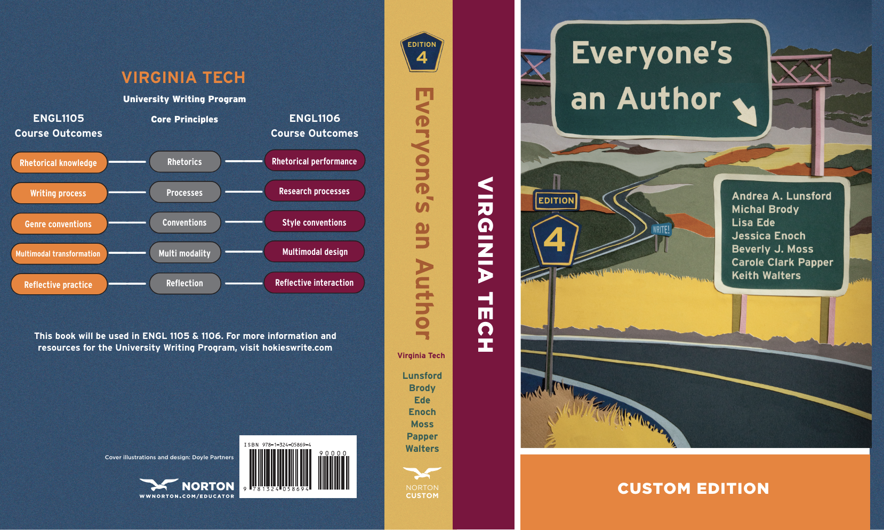

Lunsford, Andrea A., et al. *Everyone's an Author (4th Edition, Virginia Tech Custom Edition, 2024-2025)*. W. W. Norton & Company, Inc., 2024. (required). For the printed version of the textbook, the ISBN is **978-1-324-05869-4**. For the ebook, the ISBN is **978-1-324-05876-2.** eBook access will be sold to students through access codes the bookstore purchases.

This book is available in the Virginia Tech Bookstore. Copies are also on reserve in Newman Library. Supplemental readings will be available to you as PDFs and hyperlinks accessible in Canvas. You should access these materials for reading on the screen or, if you prefer, for printing and reading. Additional costs may apply for printing and photocopying over the course of the semester.

# Projects Overview

You will complete five major projects and keep a writing notebook for this course. Each of the projects will be described fully in separate prompts that I will circulate at an appropriate time in the semester. Grades on projects will adhere to Virginia Tech’s A-F system.

Project One: Digital Literacy Narrative 15%

Project Two: Reading Spaces 20%

Project Three: Worknets 25%

Project Four: Hokie Pitch 10%

Project Five: Course Reflection 10%

Writing Notebook (includes both out-of-class and in-class, low-stakes writing prompts/activities) 20%

# Grading Scale

| **A Grades** | **B Grades** | **C Grades** | **D Grades and Below** |
| --- | --- | --- | --- |
|  | B+ 87-89% | C+ 77-79% | D+ 67-69% |
| A 94-100% | B 84-86% | C 74-76% | D 64–66% |
| A- 90-93% | B- 80-83% | C- 70-73% | D- 60-63% |
|  |  |  | F 59% or below |

# Course Policies and Guidelines

## Attendance and Participation

ENGL1105 is a course in language learning, and language is learned in communities, usually by social interactions. You are expected to participate in interactive activities which may include, discussing reading assignments, writing on impromptu topics, or engaging in peer review of drafts. If you miss these activities regularly, you cannot reasonably make them up. As a result, *you should expect to receive a lower grade in the course if you do not participate regularly. If you miss more than the equivalent of two weeks of class, you should consider withdrawing and taking the class in a future semester*. I do not anticipate any of you will be in that position, however, and I would greatly prefer to see everyone become invested in the coursework, learn a lot, and make ENGL1105 a meaningful experience.

## Completing Work

My course policies for completing work are as follows:

* All work must be submitted via Canvas, in the appropriate place, by the date and time indicated for the draft to receive credit. This policy applies whether or not you are present in class on a given day.
* Assignments are due on specific dates, but you may submit them at any time during the deadline window. We’ll talk more about these specific windows later, but keep in mind your own schedules and other coursework obligations when deciding which day to submit your projects.
  + I don’t know your schedules and I do not want to force you to do things at times that are inconvenient to you. However, I do expect you to manage your own time and meet the already-flexible deadlines I give you.
* If you have to miss class for any reason, you are responsible for staying on schedule to complete all work required.
* In the event of an emergency that prevents you from completing your work, you must email me to create a “Course of Action” that details how you will get back on track and make up for missing work.
* I do not accept late work, unless it is prior approved by me.

If you have any concerns or issues about being able to complete an assignment on time, contact me as soon as possible—well in advance of the due date, not 7pm the day that it is due. If you have any questions or concerns about privacy online, or about sharing your in-class writing with others, please let me know privately, as soon as possible.

## Tech-Friendly Reminders

I am an advocate for using digital tools that help you learn, communicate, and collaborate. My tech-friendly reminders are as follows:

* Though we are not in a computer lab, I highly encourage you to bring a laptop or other device to participate fully in digital/online class activities.
* All tech use during class time should be course-related and not a distraction to yourself or others.
* Please silence your phones, or place them on vibrate if you have a specific need to do so. If you think you might have a situation that requires you to take calls during our class time, please let me know at the beginning of class that day.
* You are responsible for backing up all of your digital work. Save your work frequently, make backup copies, and plan your projects with extra time allowed for unexpected challenges. Approach me with questions about file formats and the submission process, well in advance of the due dates.

**I also prohibit the use of generative AI to write all or portions of your projects. AI is only permitted for use in the brainstorming process, if necessary and when prompted in-class. If I suspect you have plagiarized or used AI to generate any portion of your projects, I will schedule a meeting with you to discuss the appropriate course of action.**

## Communication

For major questions regarding the course, your progress in the course, or highly private or important matters, you **must** email me from your Virginia Tech email account. You will likely receive a reply back from me within 4-6 hours. Note however, I don’t always check email regularly on the weekends or after 7 p.m on weekdays.

Additionally, if you have individual questions about your work or progress in the course, I highly encourage you to meet with me during my regular office hours. You can also email me to set up an appointment to meet outside of regularly scheduled office hours.

While a fair amount of leadership and direction come from me, I strongly encourage you to identify at least two peers with whom you can confirm course details, discuss your questions or concerns, and catch up on anything you may miss during an absence. You can also send emails to me or to classmates via Canvas.

## Struggling in Class

If for any reason you feel you are struggling this term, I hope that you will feel comfortable letting me know as soon as possible. This includes anything that might affect whether or not you can participate to the best of your ability—including physical injury, medical illness, mental health, depression or anxiety, relationship abuse or violence, grief or unmanageable stress. I am not a trained counselor but can put you in touch with resources on campus to support you in whatever ways you wish.

If you know, think, or are concerned that you have a disability (temporary or permanent) that will affect your active participation in this course, I hope that you will feel comfortable letting me know privately as soon as possible so that we may arrange accommodations or get resources from the Services for Students with Disabilities (SSD) office.

# Services for You

## Principles of Community

This course adheres to Virginia Tech's Principles of Community. If you have any questions, please speak with me or consult the Principles of Community website at <https://www.inclusive.vt.edu/Programs/vtpoc0.html>.

## Cultural and Community Centers

VT offers several cultural and community centers to support underrepresented and underserved students’ well-being, academic and professional development, as well as their sense of belonging. The centers can be found in Squires Student Center and include [American Indian and Indigenous,](https://ccc.vt.edu/index/aiicc.html) [APIDA+](https://ccc.vt.edu/index/acec.html), [Black](https://ccc.vt.edu/index/bcc.html), [Hispanic and Latinx](https://ccc.vt.edu/index/el_centro.html), and [LGBTQ+](https://ccc.vt.edu/index/lgbtq.html) spaces.

## VT Women’s Center

The [Virginia Tech Women’s Center](https://www.womenscenter.vt.edu/womenscenter.html) (Yellow House at 206 Washington Street; 540-231-7806) works to foster a campus community where every person is supported and feels safe. Their counselors and advocates support students through all types of trauma including but not limited to sexual assault and other types of interpersonal violence and host many different types of programming and events to support the campus community. Follow them on Twitter and Instagram @vtwomensctr.

## Office of Veterans Services

The [Office of Veterans Services](https://www.veterans.vt.edu/) (220 Gilbert Place; 540-231-5815) collaborates with other student services on campus to provide academic and personal support, tailored to address the unique needs of Virginia Tech veterans, including building a resume, navigating through the VA Healthcare system, and identifying education benefits. The staff are committed to helping military and veteran students, their spouses, and their dependents achieve their educational goals.

## Services for Students with Disabilities (SSD)

Virginia Tech welcomes students with disabilities into the University’s educational programs. The University promotes efforts to provide equal access and a culture of inclusion without altering the essential elements of coursework. If you anticipate or experience academic barriers that may be due to disability, including but not limited to ADHD, chronic or temporary medical conditions, deaf or hard of hearing, learning disability, mental health, or vision impairment, please contact the [Services for Students with Disabilities](https://ssd.vt.edu/) (SSD) office (540-231-3788, ssd@vt.edu, or visit www.ssd.vt.edu). If you have an SSD accommodation letter, please meet with me privately during office hours as early in the semester as possible to deliver your letter and discuss your accommodations. You must give me reasonable notice to implement your accommodations, which is generally 5 business days and 10 business days for final exams.

## Counseling and Psychological Services

The [Cook Counseling Center](https://www.ucc.vt.edu) (220 Gilbert Street, Suite 2400 (0108), 540-231-6557) is dedicated to addressing the mental health needs of Virginia Tech students, providing individual counseling, group counseling, and psychiatric services. Learn more about their services online at https://www.ucc.vt.edu/.

## Dean of Students

The office of the [Dean of Students](https://www.dos.vt.edu) is committed to your overall well-being at Virginia Tech, related to a wide variety of issues, including personal or family hardship, instances of bias or discrimination, extended absences, and any other matters in which you need support and advocacy. The office assists students with adherence to policy, conflict resolution and prevention in resolving both academic and non-academic matters, providing an informal and neutral place for students to come to express any concerns. If you notice that one of your peers is struggling somehow but you’re not sure how to handle it, consider contacting the Dean of Students for suggestions. The Dean of Students helps students resolve concerns, problems, or conflicts so as to assure the best possible university experience for everyone.

Campus Address 109 New Hall West

Phone Number 540-231-3787, 8-5 p.m., Mon.-Fri.

After Hours Phone 540-231-6411, press 1

Website https://www.dos.vt.edu/

Email dean.students@vt.edu

## The Market of Virginia Tech

The Market is designed to provide food assistance to students who, for whatever reason, have a hard time obtaining regular, healthy meals. Such a situation could be the result of a short-term disruption in finances, residing in a food desert, or a lack of access to other financial assistance. To sign up for assistance visit [foodaccess.vt.edu](http://foodaccess.vt.edu), email themarket@vt.edu, or call 540-231-3787.

## Writing Center

The [Writing Center](https://lib.vt.edu/study-learn/writing-center.html) (Newman Library 2nd floor, Learning Commons); offers one-to-one writing assistance for both undergraduate and graduate students. Students can make appointments or drop in between the hours of 10 a.m. and 4 p.m. on Mon.- Fri. and 4 p.m.- 7 p.m. Wed. In addition to in-person sessions, online sessions are also available. See our website for details at <https://lib.vt.edu/study-learn/writing-center.html>.

# University Policies

## Policy on Harassment, Discrimination, and Sexual Assault

Virginia Tech is committed to supporting students and upholding the University’s Policy on Harassment, Discrimination, and Sexual Assault. Under Title IX, discrimination on the basis of sex is prohibited. If you experience an incident of sex discrimination (such as sexual assault, sex- or gender-based harassment, intimate-partner violence or stalking), we encourage you to report it. You may obtain confidential support from the Title IX Coordinator Katie Polidoro (polidoro@vt.edu; 540-231-1824). As a Virginia Tech faculty member, I serve as a Title IX Responsible Employee and thus must report any incidents of sexual misconduct and interpersonal violence involving Virginia Tech students, faculty and staff to the Title IX Coordinator regardless of whether the incident occurs on or off campus.

If you wish to discuss an incident confidentially without notifying the Title IX Coordinator, you may contact the Cook Counseling Center. For more information, see the Sexual Misconduct and Interpersonal Violence Policy at <https://policies.vt.edu/1025.pdf>, or visit the Title IX Coordinator site to request assistance at <https://oea.vt.edu/about/requesting-assistance.html>.

## Honor Code and Plagiarism

The Undergraduate Honor Code pledge that each member of the university community agrees to abide by states:

"As a Hokie, I will conduct myself with honor and integrity at all times. I will not lie, cheat, or steal, nor will I accept the actions of those who do."

Students enrolled in this course are responsible for abiding by the Honor Code. A student who has doubts about how the Honor Code applies to any assignment is responsible for obtaining specific guidance from the course instructor before submitting the assignment for evaluation. Students are strongly discouraged from misusing sites such as Chegg and CourseHero, as well as misusing ChatGPT and other Generative Artificial Intelligence. Students are strongly encouraged to consult their faculty members regarding the use of such outside materials as the misuse of these sources may constitute a violation of the Honor Code. Ignorance of the rules does not exclude any member of the University community from the requirements and expectations of the Honor Code.

Plagiarism occurs when a writer passes off another's words or ideas without acknowledging their source, whether intentionally or not. For example, turning in another's work as your own is plagiarism. If you plagiarize in this class, you will likely fail the assignment on which you are working and your case may be passed to the university for additional disciplinary action. Because of the design and nature of this course, it will take as much (or more) work for you to plagiarize in it than it will to actually complete the work of the class.

For additional information about the Honor Code, please visit: <https://www.honorsystem.vt.edu/>

**I also prohibit the use of generative AI to write all or portions of your projects. AI is only permitted for use in the brainstorming process, if necessary and when prompted in-class. If I suspect you have plagiarized or used AI to generate any portion of your projects, I will schedule a meeting with you to discuss the appropriate course of action.**

## Course Calendar

Please see the course calendar provided on Canvas for up-to-date details regarding required reading, assignments, and other course-related information!